**ITS 26000 – Applied Database Tech**

**Lab 05 – (100 points)**

**Note: Before you do the exercises of Lab 4, please reload the database scripts.**

**Use SQL to complete the following exercises.**

### KimTay Pet Supplies:

* 1. Update the credit_limit of customers whose last name is ‘smith’ to 750.00 (5 points)

UPDATE kimtay.customer

set credit_limit = '750.00'

Where last_name = 'Smith';

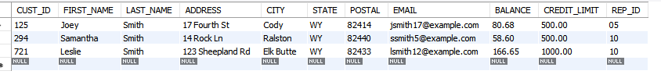

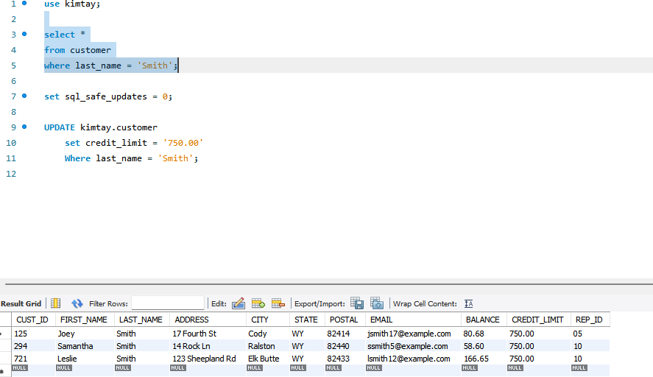

* 1. Delete the records of customers who live in ‘cody’ city. (5 points)

delete

from customer

where city = 'Cody';

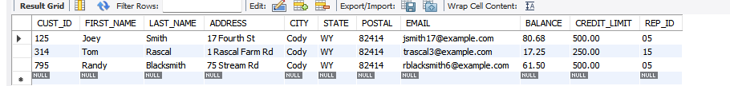

* 1. Delete the REP table. (5 points)

drop table sales_rep;

* 1. List the item ID, description, and price for all items. (5 points)

Select Item_ID, description, price

From item

* 1. List the first and last names of customers with credit limits of $1,000 or more. (5 points)

select first_name, last_name

from customer

where credit_limit >= 1000;

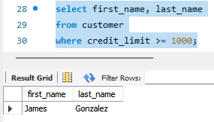

* 1. List the order number for each order placed by customer number 125 on 11/15/2021. (Hint: If you need help, use the discussion of the DATE data type in Figure 3-19 in Module 3.) (10 points)

select invoice_num

from invoices

where CUST_ID = '125' and INVOICE_DATE = '2021-11-15';

* 1. List the item ID and description of each item that is not in category HOR. (5 points)

select item_id, description

from item

where category <> 'HOR';

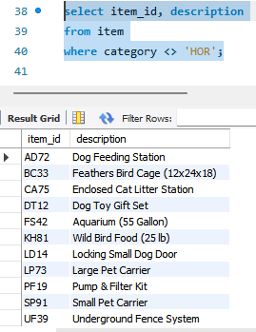

* 1. List the item ID, description, and number of units on hand for each item that has between 10 and 30 units on hand, including both 10 and 30. Provide two alternate SQL statements to produce the same results. (10 points)

1. select item_id, description, on_hand

from item

where on_hand between 10 and 30;

1. select item_id, description, on_hand

from item

where on_hand >=10 and on_hand <=30;

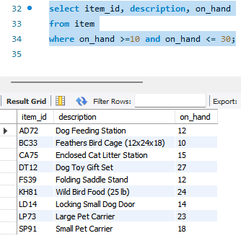

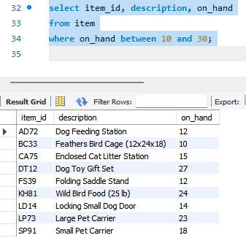

1. StayWell Student Accommodation:
   1. Update the following information for office whose office_num is 2:

Area: Redmond; Office_name: StayWell-Redmond (10 points)

update staywell.office

set area = 'Redmond', Office_name = 'Staywell-Redmond'

where office_num = 2;

before

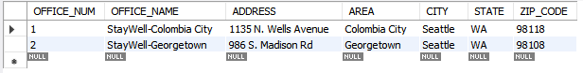after

* 1. Delete the records of the residents who live in the property with PROPERTY_ID 2. (5 points)

delete from residents

where property_id = 2;

Before

After

* 1. Delete the SUMMER_SCHOOL_RENTALS table. (5 points)
* Summer_school_rentals table does not exist.

drop table summer_school_rentals;





* 1. List the last name and first name of every owner who does not live in Seattle. (5 points)

select last_name, first_name

from owner

where city <> 'seattle';

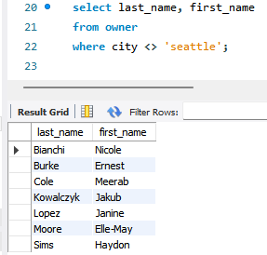

* 1. List the property ID and office number for every property whose square footage is equal to or less than 1,400 square feet. (5 points)

select property_id, office_num

from property

where sqr_ft <= 1400;

* 1. List the property ID for every property with two bedrooms that is managed by StayWell-Georgetown. (10 points) -> reloaded original database because ‘StayWell-Georgetown’ was changed to ‘StayWell-Redmond’ for above question.

select property_ID

from property, office

where bdrms = '2' and property.office_num = office.office_num and office_name = 'StayWell-Georgetown';

* 1. What WHERE clause would you use to find all service requests with the word “heating” anywhere in the description field? (10 points)

You would use where description like ‘%heating%’

select *

from service_request

where description like '%heating%';

**Deliverables**: Document Report with the SQL statement/Query and snapshot of query, its execution and results. Either word or pdf file need to be uploaded into Brightspace in one submission